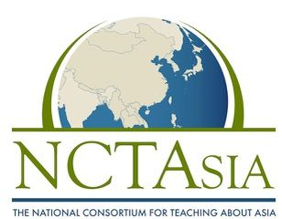 | Freeman Book Award 2024 Nomination Form
1. Title of Book:

2. Publisher:

3. Month and Day of Publication:

4. Grade level nomination (Please check one only):
a. Children’s Literature (picture book up to grade 5) ____________
b. Young Adult (grades 6-12) __________________

5. Comments or description of book:

6. Publishers, please supply:
a. Name of contact person:

b. Email:

c. Phone:

d. Mailing address:

7. Teachers or librarians, please supply:
a. Name:

b. Email:

c. Grade level and subject(s) taught:

d. School or organization affiliation:

Questions: Please contact Nancy Hope by email only at nancy.hope@nctasia.org.

